**DAILY ONLINE ACTIVITIES SUMMARY**

|  |  |  |  |  |  |  |  |  |
| --- | --- | --- | --- | --- | --- | --- | --- | --- |
| **Date:** | **18/05/2020** | | | | | **Name:** | **Katira Krishna J** | |
| **Sem & Sec** | **8th A** | | | | | **USN:** | **4AL16CS045** | |
| **Online Test Summary** | | | | | | | | |
| **Subject** | | **SMS** | | | | | | |
| **Max. Marks** | | **60** | | **Score** | | | **55** | |
| **Certification Course Summary** | | | | | | | | |
| **Course** | **Big Data 101** | | | | | | | |
| **Certificate Provider** | | | **Cognitiveclass.ai** | | **Duration** | | | **90 mins** |
| **Coding Challenges** | | | | | | | | |
| **Problem Statement: 1) Print frequency of each character 2)Print odd and even number series respectively from two threads** | | | | | | | | |
| **Status: Completed** | | | | | | | | |
| **Uploaded the report in Github** | | | | | **yes** | | | |
| **If yes Repository name** | | | | | **Krishna_Katira** | | | |
| **Uploaded the report in slack** | | | | | **yes** | | | |

Online Test Details:

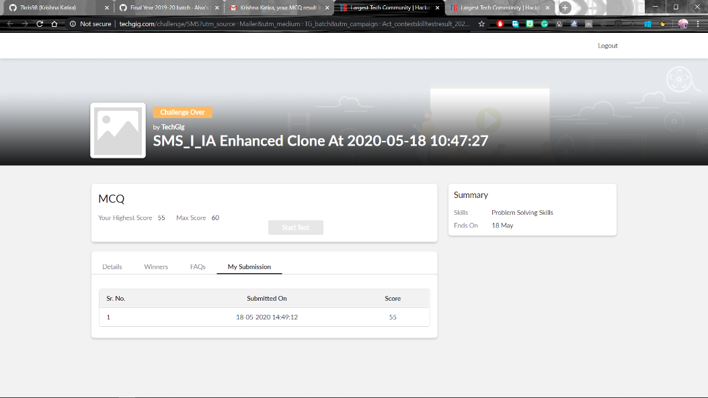

Certification Course Details:

Beyond the hype of the term 'Big Data', this course shows how Big Data is being adopted in different industries. When you complete this course and earn a badge, you will have a greater understanding of what Big Data is, how it can impact different businesses and, some of the technology used to manage Big Data.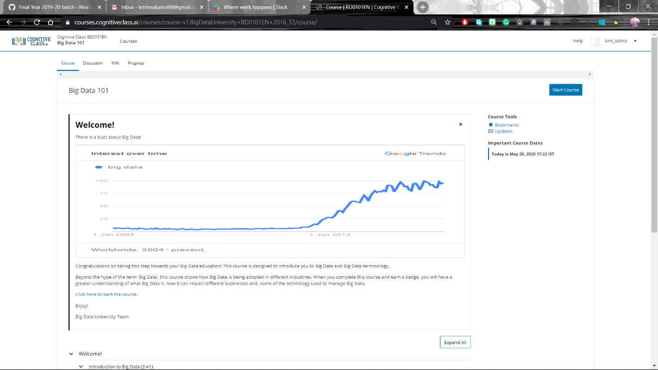

Coding Challenges Details:

**program1:**

.import java.util.Scanner;

public class StringOperators

{

public static void main(String args[])

{

int i;

String str;

int counter[] = new int[256];

Scanner in = new Scanner(System.in);

System.out.print("Enter a String : ");

str=in.nextLine();

for (i = 0; i < str.length(); i++) {

counter[(int) str.charAt(i)]++;

}

// Print Frequency of characters

for (i = 0; i < 256; i++) {

if (counter[i] != 0) {

System.out.println((char) i + ":-" + counter[i] + " times");

}}}}

2.public class PingPong extends Thread {

static StringBuilder object = new StringBuilder("");

public static void main(String[] args) throws InterruptedException {

Thread t1 = new PingPong();

Thread t2 = new PingPong();

t1.setName("\nping");

t2.setName(" pong");

t1.start();

t2.start();

}

@override

public void run() {

working();

}

void working() {

while (true) {

synchronized (object) {

try {

System.out.print(Thread.currentThread().getName());

object.notify();

object.wait();

} catch (InterruptedException e) {

e.printStackTrace();}}}}}